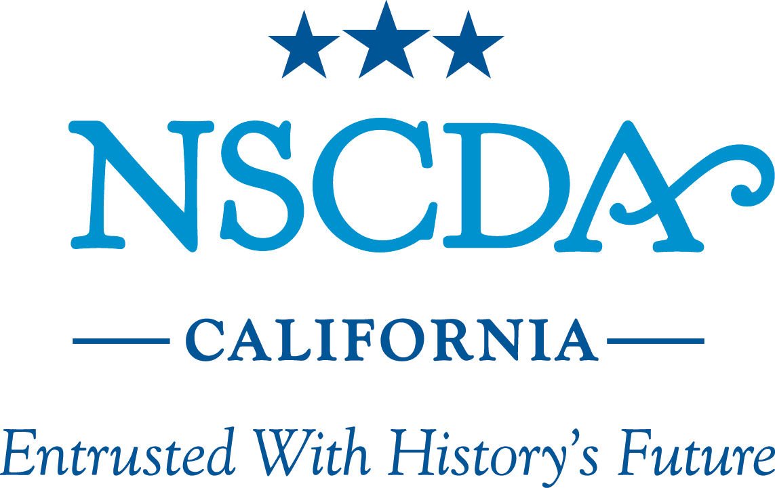

The National Society of The Colonial Dames of America in California

State Semi-Annual Meeting La Jolla Country Club
January 23, 2014 San Diego, California

AGENDA

Welcome and Introductions: Mrs. Douglas Bruce Gordon
Fourth Vice President, NSCDA-CA and
San Diego Town Committee Chairman

Approval of 2013 Semi-annual Meeting Minutes

Town Committee Reports:

• Los Angeles-Pasadena-Santa Barbara Mrs.William D. Burrows, Chairman
• Monterey Peninsula Mrs. Jeffrey M. Riehl, Chairman
• San Diego Mrs. Douglas Bruce Gordon, Chairman

Sulgrave Manor Mrs. Cecelia R. Cole
Associate Trustee of the Friends of Sulgrave Manor

Dumbarton House Mrs. Stuart C. Marshall
Dumbarton House Board Member
Treasurer's Report Mrs. Patricia E. Anderson Historian Ms. Marguerite V. Meyer Recording Secretary Ms. Elizabeth L. Wolfensperger Corresponding Secretary Mrs. George Arthur Fish, Jr. Membership Mrs. J. Christopher Matthews Patriotic Service & Historical Activities Ms. A. Campbell Merrifield Registrar Mrs. James Richard Dickson President's Report Mrs. Stanley K. Sollid,
President, NSCDA-CA

Website Presentation Ms. Marguerite Wilbur Christiansen

Announcements and Adjournment

Salute to the Flag
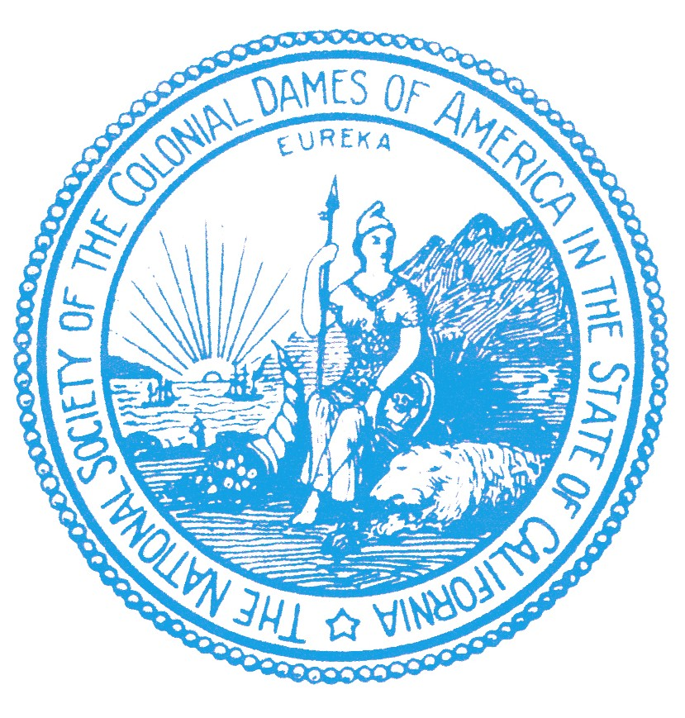

To the glory of God, and in grateful remembrance of those, our ancestors, who, through evil report and loss of fortune, through suffering and death, maintained stout hearts and laid the foundations of our country, we, The National Society of The Colonial Dames of America, pledge our loyal and affectionate allegiance to the Flag.

